LIFE IS BETTER CONSULTING COMPANY

Analysing The Best Fit Strategic Plan For Life is Good Company

Group number 10:

Vionita Suryawijaya (12418069)

Kim Jun Kyo (12218393)

Ngo Dang Hoang (12418025)

Pham Thi Xuan Hang (12418167)

Riku Yoshimoto (12219251)

Nguyen Xuan Binh (12418064)

Mark Ian Hovden

Bat-Undral Dorjsambuu (12418038)

Zahra Dyah Kamila (12418209)

Le Nguyen Bao Chau (12418104)

**Introduction to Marketing**

**Professor Chen Shu-Ching**

**July 4th 2019**

**RITSUMEIKAN ASIA PACIFIC UNIVERSITY**

**Beppu, Japan**

**Table of Contents**

Table of Contents………………………………………………………………………… i

Executive Summary ……………………………………………………………………... iii

1. Company Profile……………………………………………………………………….. 1

1.1 History....…………………………..…………………………………………. 1

1.2 Products……………………..………………………………………………... 1

1.3 Customer...…………………..………………....……………………………... 1

1.4 Consumer……………………..………………………………………………. 2

1.5 Competitor……………………..……………………………………………... 2

2. Core Competencies……………………..…………………………………………….... 3

2.1 Well Practiced Corporate Social Responsibility ……………………..………. 3

2.2 Altruistic Mission Statement ……………………..…………………………... 3

2.3 Flexible to New Collections…………………………..………………………. 3

3. Current Business Portfolio Analysis……………………..……………………………... 5

3.1 Business Portfolio……………………..………………………………………. 5

3.2 Strategy for Growth……………………..…………………………………….. 6

3.2.1 Market Penetration……………………..…………………………… 6

3.2.1.1 Developing Online Contents ……………..……………….. 6

3.2.2 Market development ……………..…………………………………. 6

3.2.2.1 Targeting a different demographic segmentation…………. 6

3.2.3 Product Development ………………………………………………. 6

3.2.3.1 Collaboration with cartoon characters …………………… 6

3.2.3.2 Collaboration with celebrities and inspiring quotes……… 7

3.2.4 Diversification ……………………………………………………... 7

4. SWOT Analysis for Life is Good Company …………………………………………... 8

4.1 SWOT…………………………………………................................................ 8

4.1.1 Life is Good company’s Strengths…….............................................. 8

4.1.2 Life is Good Weaknesses……............................................................ 8

4.1.3 Life is Good Opportunities…….......................................................... 8

4.1.4 Life is Good Threats…….................................................................... 9

4.2. Life is Good’s Opportunities that match Core Competencies……................. 9

4.3. Converting weaknesses into strengths. ……................................................... 9

4.4. Converting Threats into Opportunity……....................................................... 9

5. Mission Statement……...............................................……............................................ 10

5.2 Marketing Objectives……...............................................……......................... 10

5.3 Integrated Marketing Mix……......................................................................... 10

5.3.1 Product……....................................................................................... 10

5.3.2 Place…............................................................................................... 10

5.3.3 Promotion…....................................................................................... 10

5.3.4 Price…................................................................................................ 11

6. Justification….................................................................................................................. 12

6.1 Current Problem .......................................…..................................................... 12

6.2 Our Solution .......................................…........................................................... 12

6.3 Our Reason .......................................…............................................................. 12

6.3.1Producing more online content to reduce cognitive dissonance……. 12

6.3.2 Collaborating with celebrities to improve brand recognition………. 13

6.3.3 Collaboration with cartoon characters to recall nostalgic memories.. 13

6.4 Expected Outcome ..................…..................................................................... 14

Reference…......................................................................................…................................ 15

**Executive Summary**

The following analysis provides better insight into the current performance of Life is Good (LIG) company. Despite having a good brand message,  LIG faces several challenges of not being unique enough, not being famous enough, and not being trustworthy enough.

By conducting research and SWOT analysis, we soon realized that the predicaments can be utilized to be opportunities, and their strengths can be enhanced. Hence, we devised a practical marketing strategy to help LIG to improve their business. Following is our suggestions.

1. Collaborating with celebrities to improve brand recognition and uniqueness.
2. Collaborating with cartoon characters to penetrate different age demographic segments.
3. Producing more online content to reduce cognitive dissonance.

We believe that those three approaches would be the best solutions to overcome current predicaments. The expected outcomes are improved brand recognition and uniqueness, increase the customer range, and reduce cognitive dissonance. With this outcome, we believe that LIG can further enrich their business and events to serve people in need while being successful in delivering the brand message.

**1. Company Profile**

**1.1 History**

Life is Good Company was founded by Bert and John Jacobs. Starting from selling shirts to college students in 1988 in The United States to opening an official apparel brand which promotes the power of optimism internationally. Currently, the company has around 160 employees, 4,500 retailers and grossed $100 million in sales (Whitten, 2015). Life is Good has created a campaign of donating 10% of its annual profits to help children with disadvantages.

**1.2 Products**

Life is Good possesses a variety of consumer products with creative, simple and dynamic graphic design and logos.

*Picture 1.2 Life is Good Products Examples*

The company provides products that are appropriate for all ages. Life is Good product mix consists of clothing, hats, accessories, home decoration items, dolls, beach gears, tire covers, bikes, and books, which have long length and deep depth in each product line.

**1.3 Customer**

Life is Good focuses on millennials and retailers as their main target customers. Starr (2015) said Life is Good retained their middle-aged and above customers using Life is Good products for more than 20 years. Retailers also play a big role in Life is Good’s customer scheme. Life is Good sells its product to over 4500 retailers and online stores with their largest retailer being Hallmark Gold Crown. Almost every Hallmark chain (Paula’s Hallmark, Amy’s Hallmark) in the USA and Canada became a retailer for Life is Good products.



*Picture 1.3 Life is Good Largest Retailer*

**1.4 Consumers**

Life is Good targets the market without any gender barriers. Their major consumers are teenagers and parents with young children with middle-class to upper-middle-class income level. Specifically, Life is Good focus more on consumer aged between 18-24 and kids. As said by CEO Bert Jacobs adolescents are the ultimate optimism. The company aims at people who are interested in the perceived optimistic mindset (Bloomberg L.P., 2019)

**1.5 Competitor**

Life is good has set their customer value in improving customer confidence and positivity by spreading optimism through wearing their brand. Being a lifestyle brand, Life is good weaves their message into their wide range of products from T-shirts, accessories to home decor items. However, Many other apparel brands with a similar range of price also promote a certain lifestyle like Life is Good such as Nike (sporty, healthy lifestyle) or ASOS (spreading body-positivity, self-loving lifestyle). Furthermore, considering a wider aspect, Life is Good has to compete with many big names in the apparel, casual wear industry sharing the same demographic customer’s target such as GAP and H&M. Although those apparel industries are examples of their product competitors, Life is Good faces higher competitors such as Zappos, an apparel store that set “Delivering Happiness” as their company mission (Yohn, 2016). This is one of the competitors that challenges Life is Good ideology.

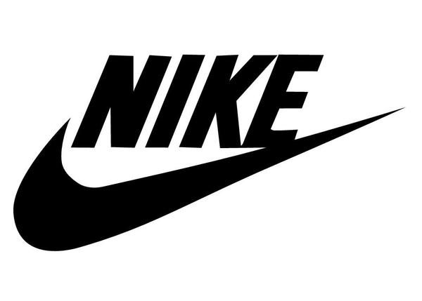   

*Picture 1.5 Life is Good Competitors*

**2. Core competencies**

The followings are the core competencies of Life is Good company that allows Life is Good to have a competitive advantage, differentiating themselves from other firms.

**2.1 Well Practiced Corporate Social Responsibility**

Life is Good organizes charitable events and donates 10% of its annual profits to help children with disadvantages (Life is Good, 2019) and camps for families (Buchanan, 2006) which are in sync with the company’s marketing message, thus boosting the company’s public profile.

**2.2 Altruistic Mission Statement**

With the mission to spread optimism across the world, Life is Good focuses not only on profits but also on their communities where people practice and share optimism. While some other corporates seek for more income, Life is Good company rather considers their customer, shown throughout various events and supports. The altruistic mission statement allows Life is good to build a strong customer relationship and brand loyalty, thus excelling compared to other companies.

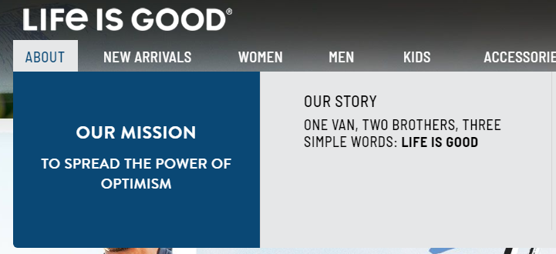

*Picture 2.2 Life is Good Company Mission*

**2.3 Flexible to New Collection**

LIG has various collections and they are making even more shown through their openness to customer’s design (Life is Good, 2019). Creating many collections to attract different customers is one of the well-demonstrated competencies of LIG.

*Picture 2.3.1 Life is Good T-shirt Designing Contest.*

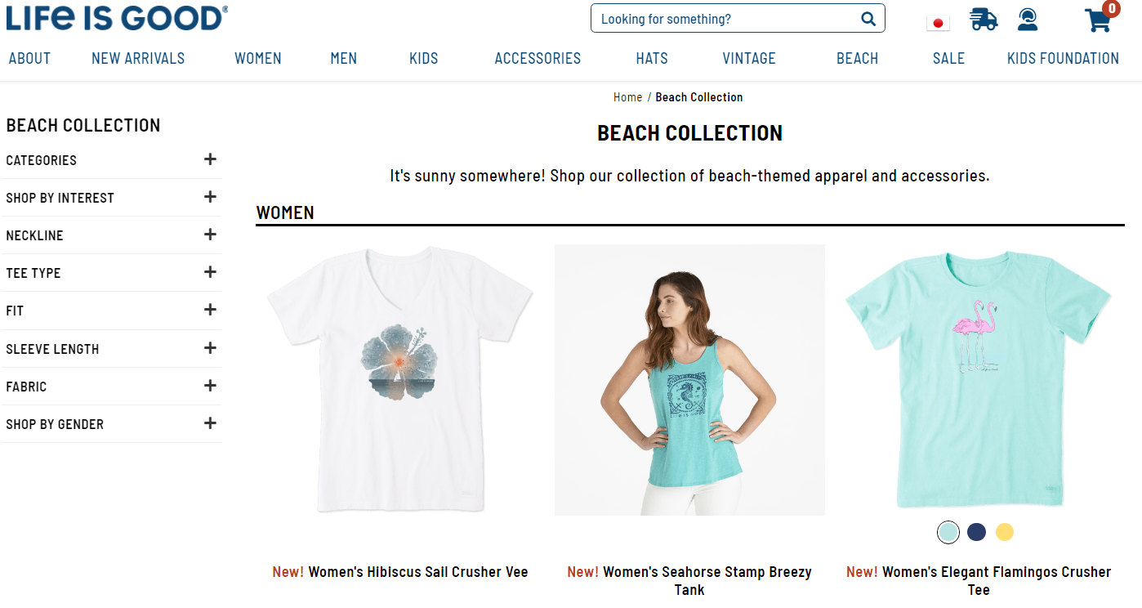 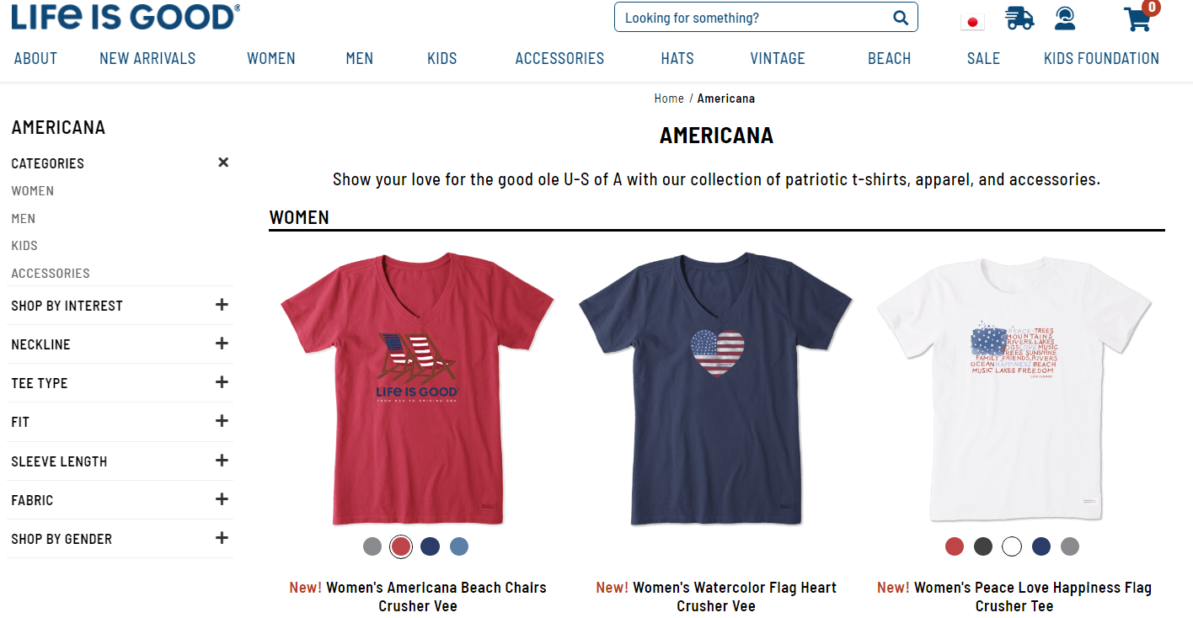

*Picture 2.3.2 Life is Good Collections example*

**3. Current business portfolio analysis**

**3.1 Business Portfolio**

Most customers know Life is Good for its optimistic T-shirts and hats, many of which feature a smiling stick figure named Jake and the registered trademark “Life is Good.” They offer over 900 different items in 14 categories.

|  |  |  |
| --- | --- | --- |
| BCG Matrix Analysis | | |
| https://docs.google.com/drawings/d/sDLYrsAFeWTOn_IxV2U9Xhw/image?w=60&h=372&rev=1&ac=1&parent=1A76pjppCXfH47mH8SlWKlpTfLmyhlYhdTUCHXSDK-tc | Star | https://lh5.googleusercontent.com/Y7jumpM3PCdGbr5kc0m5XGIyQDE2fbid87Ob7pIzO5xcf3O4t8RiX0aQBDkJFFK-KBmzSgepGbkiGn3beyYy4yhoV2MKXtzItF6xgyZWSlcHK5__zD1xSkD782Pys0Vi1WEihptv  Question mark  Phone cases |
| https://lh4.googleusercontent.com/66-UHCNXjiqWs8YHUlsr_ATlcUTNc3GNm3e6-hKKRkp39GKYNVXK4MpvVOnuUszMel2bIzUHlT1KKreSdh0uroKPyL183In7F-bRspbEy5pQGqrcjXwtQ-hb_lW320AarDmRz8b2https://lh5.googleusercontent.com/NBvZ4YGEn1_DpZeyNO40PPf76QKRDRETwZoy13BUAN2N6lbfSg6oX2FZ-5gxSa5a-vgkSwgf67WY_FaakLv4u0vrb9Pu2LM3IY7Igz1c9jpSH5Y7MW7UD3y_UWMLytdYdHEbie9L    Cash cow  T-shirts, pants | https://lh5.googleusercontent.com/tKO1YA_vBU9xZ7UyW-s4adkqpBETqGzCSjt-kVCVvu4ou9H92s1X4MWWcl3MTiPReiuGbG9_Z56WFETO4EeJWif_-OFL1JfmvjC0iEoz706az6OgiGYsfLhawBPFvD2poDw5_5obhttps://lh5.googleusercontent.com/ha4VL3qLRrSsZ3ez0G26uhngR0nPRr24OKPk-PftKcWIcGRdc322GfM0sWcdLVhZbxxxoGl-b1yo55eZH92553ii5ztvjLZPbnYnYfrZ1wA1oz1c4bFUMekrmYzFXSEROlg-1RMGhttps://lh3.googleusercontent.com/2Cj_DglBtSnB13jugwAuOOlq2TFGIyi-y_bGjx8fq5sl56ZXEqB2JvZoQQe6jtKxsJQ-Nodd1J8AINqYkJPLCYMr5rD4bRLg95rU98thxp8eWMkl55e2dQ9-sbToqfMrYbA3lZg1https://lh4.googleusercontent.com/oconbnu9_rG0JYhCaHlGNHbGfvqRsv0HogxW1N0t3BGf3VKYT5eb7_A_3vS-kyHj39Y3hGTHAgNnPgoCXMs9_xBOxd2E3mpw5ASbFde-TTdVqgGoI9G5Rtco7cRSe75pNUuOzmzA  Dog  Schwinn bikes, tire covers, beach gear, stickers and magnets |
|  | https://docs.google.com/drawings/d/sZmxMZAOyxk0WWgvhUWzAzw/image?w=360&h=58&rev=65&ac=1&parent=1A76pjppCXfH47mH8SlWKlpTfLmyhlYhdTUCHXSDK-tc | |

*3.1 BCG Matrix Analysis table*

Star : Life is Good has no product in star category because even though they have 4500 retail stores throughout the U.S and Canada, currently, none of the product has high market growth rate and relative market share.

Cash Cow : Although Life is Good is facing a lot of competitors in the clothing industry, the Company still has a large market share in this product. Meanwhile, T-shirt and pants for example already reached its static market growth.

Question Mark: With the current increasing demand for smartphones, phone cases growth rate

become higher too. Yet, Life is good is currently does not have a high market share on their phone case product.

Dog : Life is good has many products and most of them are still in the dog category.

Taking an example from stickers and magnets, these products do not possess enough market share and growth to actually generate decent revenue for the company.

**3.2 Strategy for the growth**

**3.2.1 Market Penetration**

**3.2.1.1 Developing Online Contents**

LIG should develop original online content, associating with scholars and writers such as Martin Seligman from Learned Optimism, and Mihaly Csikszentmihalyi from Flow. LIG should also appear on radio talk shows to promote their products as 88% of American own a car (Misra, 2015).

**3.2.2 Market Development**

**3.2.2.1 Targeting a different age group of demographic** **segmentation**

LIG should expand their targeting groups to different age groups such as Baby Boomers Gen X, and Gen Y by causing nostalgia, focusing on Baby Boomer as the baby boomer generation is a relatively untouched client base.

**3.2.3 Product development**

**3.2.3.1 Collaboration with cartoon characters**

To create nostalgic emotion, LIG should collaborate with the cartoon studios like Pixar, DreamWorks,... For example, including Garfield in promotion could provoke nostalgia in Baby Boomer to Gen X

**3.2.3.2 Collaboration with celebrities and inspiring quotes**

LIG should produce limited edition products with inspirational quotes from celebrities. This would create a new star in BGC analysis if planned correctly.

**3.2.4 Diversification**

As LIG product lines are already diversified enough, there is no need for LIG to expand more. It will be overexpansion and hurt the business (Young, 2013).

**4. SWOT Analysis of Life Is Good Company**

**4.1 Swot Analysis**

**4.1.1 Life is Good company’s Strengths**

Though starting as an apparel brand with a simple product like T-shirt, LIG grew fast and has stayed authentic with its original aim which is spreading the power of optimism. The idea is original and positive which creates a strong customer base. LIG also participates in improving social and environmental issues which strengthens the company image.

**4.1.2 Life is Good Weaknesses**

LIG does not stand out as having a unique and memorable style compared to its competitors. This does not leave a long-lasting impact on the customers, which decreases the values of its products.

LIG has limited brand recognition outside of America due to being a relatively small company.

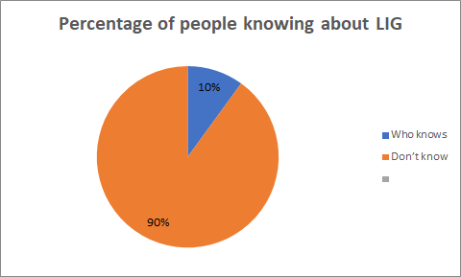

*Survey conducted by Vionita Suryawijaya in outside APU (May 15th, 2019)*

Other weakness that LIG has limited the target market, focusing on teenagers and their parents. With only such a limited market target, expecting market growth could be unrealistic.

**4.1.3 Life is Good Opportunities**

In this globalizing world where influencers can impact on consumer buying behavior, LIG’s opportunities weighted in collaboration with well-known figures.

Making better use of online platform to connect with LIG’s customers can be a huge advantage if used correctly. Most people convey and receive information through the online platform in our current world. Hence, by utilizing those platforms like radios, YouTube, and Tumblr, LIG can improve customer relations and satisfaction.

**4.1.4 Life is Good Threats**

Currently, LIG suggests an idea that the customer can feel the power of optimism by purchasing their products and believe in the ideology. However, LIG has not yet provided specific methods to become optimistic. This may disengage customers from the company when the customer realizes the marketing strategy of the company, resulting in cognitive dissonance. Continuously losing customers could be a serious threat for this company since the company needs zealous followers who believe in their ideology.

**4.2. Life is Good’s Opportunities that match Core Competencies**

Since LIG company is very flexible about creating collections, collaborating with influencers or famous media seems plausible. This could lead LIG to have better brand recognition.

**4.3. Converting weaknesses into strengths**

LIG’s weak brand recognition can be improved by collaborating with famous celebrities, and designers to increase its exposure to customers. In order to make LIG unique, they have to focus most of their resources and manpower to one section in order to consolidate and strengthen that section. This will give LIG a brand identity.

LIG should focus on other target groups like Baby Boomers, Gen Z and Gen X, as it will attract more potential customers and increase LIG’s profit.

**4.4. Converting Threats into Opportunity**

Cognitive dissonance takes place when the value proposition and actual experience doesn't match and that describes the current situation of LIG. Even though LIG addresses the importance of spreading the power of optimism, they don’t elaborate on specific ways of achieving such things and this could cause cognitive dissonance and low customer satisfaction.

Also, with the shifting paradigm of how people search for information online, making online video contents could be a good opportunity to gain good consumer satisfaction.

Therefore, making good online contents about the specific method to achieve utilizing the power of optimism would be a good opportunity to exploit.

**5. Mission statement**

**5.1 Mission Statement**

***“Reinforce, strengthen the power of optimism through online content, collaboration, and nostalgia.”***

* 1. **Marketing Objectives**
     1. Producing more online content to reduce cognitive dissonance
     2. Collaborating with celebrities to improve brand recognition.
     3. Collaborating with cartoon to penetrate different age demographic segments

**5.3 Integrated Marketing Mix**

**5.3.1 Product**

Our strategy would be focusing more on the vintage part of LIG’s products. The new products would include cartoon characters enjoyed among all group ages such as Tom & Jerry for baby boomers and Adventure Time for Millennials. LIG will also focus more on creating a nostalgic, vintage look of their products. This will form the identity for LIG which it is severely lacking.

LIG should also follow the trend of releasing limited clothing. Supreme is a great example of this (Mikhaylov, 2016) and it is now an icon in fashion. The clothes will include famous celebrities who have inspirational quotes. Those merchandises will be sold in limited quantity and distributed in exclusive stores. The shirts will be designed by famous designers with eco-friendly materials.

**5.3.2 Place**

We will put half of the limited clothes in online stores and customers can buy them in the form of auction. The rest will be sold in special outlets, revenues with the appearance of influencers and designers.

For the vintage clothes, LIG will create a separate online shop that separates from the original store. The new vintage clothes should be prioritised in retail stores to create a fresh look

**5.3.3 Promotion**

Our strategy is creating animation videos with old cartoon characters such as Tom & Jerry and Charlie Brown, posting them on social media platforms, promoting them on radio, billboards, and building screens. Collaborating with celebrities could also be a good promotion.

**5.3.4 Price**

The limited quantity product will be sold at a reasonably higher price compared to normal products. However, the vintage products will be at the same price as LIG’s old products.

**6. Justification**

**6.1 Current problems**

Although LIG has a lot of retailers throughout The U.S. and Canada, and their customer base is limited there. Most people outside of North America do not know about the existence of LIG, even in North America, few people know about LIG. In addition, the current market has not yet covered all of the age demographic categories that have potential in generating more revenue for LIG company. There is a lot of potential for LIG and proper planning and strategies would definitely push LIG to be a powerhouse in the market.

**6.2** **Our suggestions**

6.2.1 Producing more online content to reduce cognitive dissonance.

6.2.2 Collaborating with celebrities to improve brand recognition.

6.2.3 Collaborating with cartoon to penetrate different age demographic segments.

**6.3 Our Reasons**

**6.3.1 Producing more online content to reduce cognitive dissonance**

If the customer experiences the cognitive dissonance, they will be dissatisfied to the brand because the company fails to bring the value that they promised. Moreover, the company will also lose its reputation because of those unsatisfied customers. LIG’s Therefore, rather than hoping for customers to be satisfied by their current value proposition, LIG can take a further step to make a practical suggestion to be optimistic and utilize the power of optimism.

Also, when it comes to searching for information, people are shifting to search video more than worded information, and since the video is the future of searching information, conveying useful information to the customers is essential for the company’s survival. Thus, LIG should provide the visualized information, everything about optimism because they have to position themselves as the leader of optimism. The practical suggestions and methods will increase the understanding of customers. When the customers understand the full contents of what LIG offers, there will be less cognitive dissonance and more customer satisfaction.

**6.3.2 Collaborating with celebrities to improve brand recognition.**

As social influencers hold a strong impact on consumer buying behaviour, LIG company should grasp the opportunity and collaborate with these influencers who have quotes about the optimism. For example, LIG can collaborate with a well-known figure, Will Smith, by using his optimistic quotes for LIG product design. Will Smith is known to be an optimistic figure, who promotes environmental protection, donating to charities. Since his ideology aligns with that of LIG, featuring Will Smith and make a shirt design with the quote like the following would be a good idea for brand recognition.

*“Wake up positive, face your fears.”*

* Will Smith (Motivation Madness,2018)

By collaborating with famous figures who have optimistic quotes, LIG can make new product designs that are appealing to customers. LIG can also increase its brand recognition in the society. Furthermore, if Will Smith uses LIG product, it will implicitly promote the LIG brand and lures his fans to LIG’s products.

To maximize this opportunity, LIG should make those products to be very limited quantity.  It will lessen the cost if those products fail, but if they succeed, it will create a new path for LIG. The limited products will create scarcity and rareness, and people will rush to buy the product as soon as possible before LIG runs out of stock.

**6.3.3 Collaboration with cartoon characters to recall nostalgic memories**

As the population is aging with the longer life expectancy, expanding their target consumers to seniors might be a good strategy, considering that optimism is a need for everyone regardless of age.

Currently, LIG only focuses on teenagers without expanding to other age demographic segments. LIG can expand their target customers to baby boomers by collaborating with cartoon characters. It would attract baby boomers interest in buying their product because of the nostalgia they have. This will increase the uniqueness of the brand and brand loyalty of the customers.

**6.4 Expected Outcome:**

The expected outcomes are improved brand recognition and uniqueness, increase the customer range, and reduce cognitive dissonance. With this outcome, LIG can further enrich their business and events to serve people in need, while being successful in delivering the brand message.

**References**

Andrea Lo. (2018, June 5). How a positive statement made millions for this T-shirt company.

Retrieved from [https://money.cnn.com/2018/06/05/smallbusiness/life-](https://money.cnn.com/2018/06/05/smallbusiness/life-is-good-lifestyle-brand/index.html)

[is-good-lifestyle-brand /index.html](https://money.cnn.com/2018/06/05/smallbusiness/life-is-good-lifestyle-brand/index.html) on May 12, 2019.

Bloomberg L.P. (2019, May 04). *Company Overview of Life is Good, Inc.* Retrieved from

Bloomberg L.P Database: [https://www.bloomberg.com/research/stocks/private/snap shot](https://www.bloomberg.com/research/stocks/private/snap%20shot).asp?privcapId=21875530 on May 12, 2019.

Buchanan, Leigh. (2006). *Life Lessons.* Retrieved from, <https://www.inc.com/magazine/2006>

1001/life-lessons.html on May 12, 2019.

Georgiou New York, K. (2016). Instagrab: Is Instagram the most powerful tool in fashion?

Retrieved from <https://www.independent.co.uk/life-style/fashion/instagrab-is-instagram-the-most-powerful>-tool-in-fashion-a6996231.html on May 12, 2019.

Hill, C. (2017). *4 Clothing Brands That Started Off Small*. Retrieved from <https://creativere>

sources.threadless.com/clothing-brands-that-started-sma on May 3, 2019.

Kotler, P., & Armstrong, G. (2018). *Principles of Marketing*. Harlow: Pearson Education

Limited. on May 15, 2019.

Life Is Good. (2019). Life Is Good. Retrieved from <https://www.lifeisgood.com/> May 12, 2019.

Life is good, Inc. - Company Profile, Information, Business Description, History, Background

Information on Life is good, Inc. (n.d.). Retrieved from <https://www.referenceforbusine>

ss.com/history2/53/Life-is-good-Inc.html#ixzz5n1ciRGf9 May 12, 2019.

Mikhaylov, A. (2016). *Medium Corporation*. Retrieved from Medium Corporation Web site:

<https://medium.com/@antonmikhaylov/why-is-supreme-always-sold-out-17bdf782a4>

7 on July 4, 2019

Misra, T. (2015). *Global Car, Motorcycle, and Bike Ownership, in 1 Infographic*.

Retrieved from City LabWebsite: <https://www.citylab.com/transportation/2015/04/>

global-car-motorcycle-and-bike-ownership-in-1-infographic/390777/

Osmanay, Anna. (2015). Gap Inc.: Marketing Strategy Analysis of the Company. Retrieved

From <https://www.academia.edu/19985431/Gap_Inc._Marketing_Strategy_Analysis_>

of_the_Company on on June 10, 2019.

Share the good. Shift the conversation. (n.d.). Retrieved from <https://www.lifeisgood.com/som>

ethinggood on May 5, 2019.

Shipe, Jules. (2012). Gap and Jcrew Prices. by: Jules Shipe, Alexis Nesselroad, and Michelle

Lancaster. Retrieved from <https://www.statcrunch.com/5.0/viewreport.php?reportid=>

28594 on May 24, 2019.

Stainforth, Oliver. (2016). *Why Video is Transforming the Future of Research.* Retrieved from

<https://www.goup.co.uk/content-marketing/learn/why-video-is-the-future-of-search/>

on June 10, 2019.

Starr, E. (2015) *Life is Good Goes for Grand*. Retrieved from E. Star Associates:

<https://estarrassociates.com/life-is-good-goes-for-grand-brand-in-adolescence-plans-for-future/> on June 10, 2019.

Walters, N. (2016). *The fascinating story of how 2 brothers went from running a*

*failing business out of a van to building a $100 million company*. Retrieved from Business Insiders: <https://www.businessinsider.com/the-success-story-of-life-is-good-> on May 24, 2019.

Whitten, Sarah. (2015). *Life is Good 100 Million Ad-free Global Success Story.* Retrieved from

<https://www.cnbc.com/2015/05/19/life-is-good-for-bert-and-john-jacobs.html> on May

3, 2019.

Yohn, Denise Lee. (2016). *Delivering Happiness -- Company Mission And Community*

*Movement.* Retrieved from <https://www.forbes.com/sites/deniselyohn/2016/01/27/de>

livering-happiness-company-mission-and-community-movement/#73c83a343467 on June 30, 2019.

Young, C. (2013, January 28). *American Express Cormpany*. Retrieved from American

Express Web site: <https://www.americanexpress.com/en-us/business/trends-and->insights/articles/business-growing-pains-7-ways-rapid-growth-can-kill-your-business/

Zappos. (2019). *Zappos*. Retrieved from <https://www.zappos.com/> on June 30, 2019.